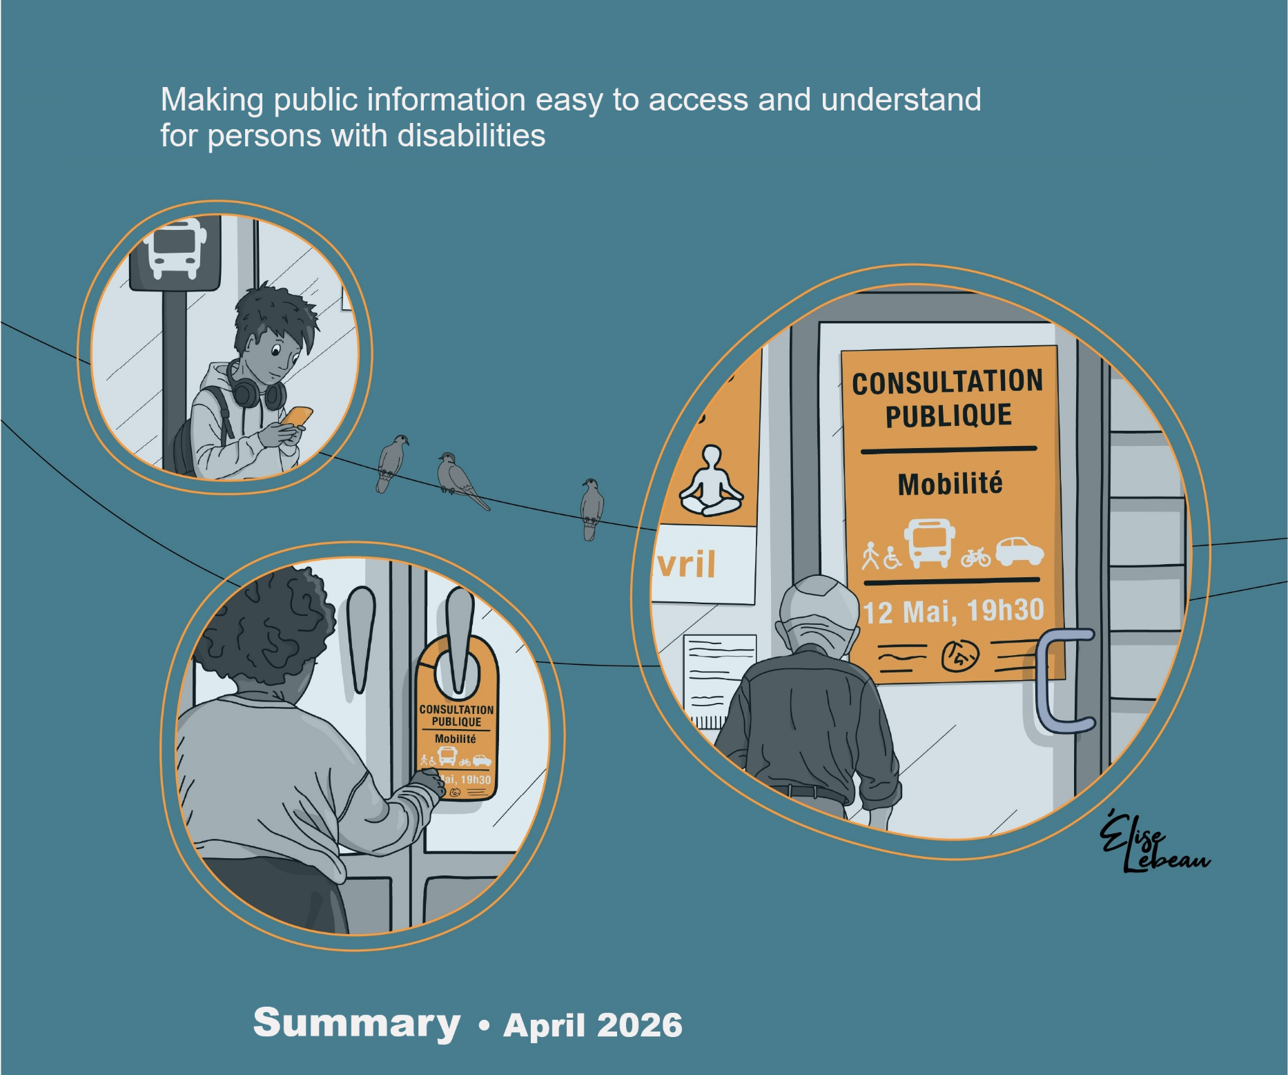

Edith Jolicoeur, Julie Ruel, Marie-Josée Goulet, Marie-Ève Gonthier, Francine Julien-Gauthier

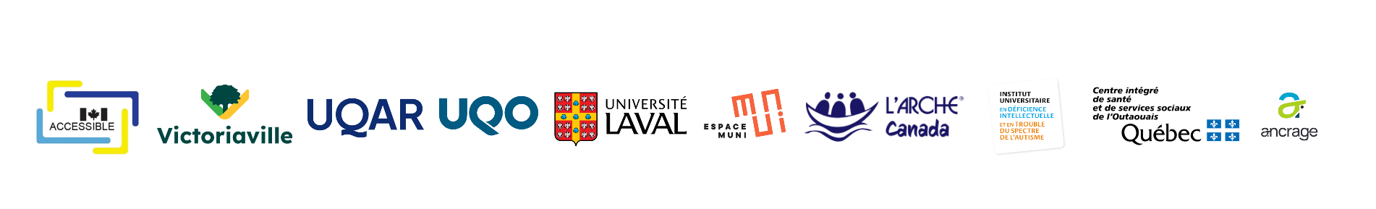
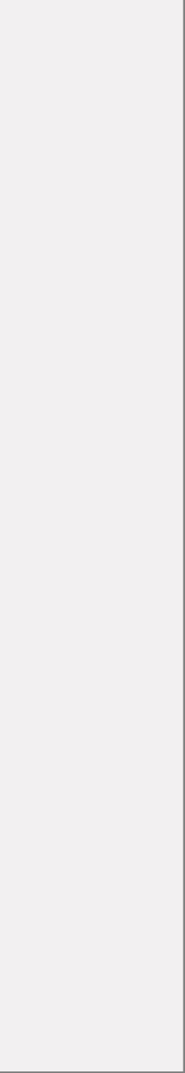
This document is an appendix to:
Jolicoeur, E., Ruel, J., Goulet, M.-J., Gonthier, M.-E., & Julien-Gauthier, F. (2026). Making public information easy to access and understand for persons with disabilities: Summary. Université du Québec à Rimouski. https://doi.org/10.65130/v9wf2nr

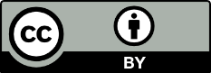
This document is published under a Creative Commons Attribution 4.0 International (CC BY 4.0) license. You are free to share and adapt it, provided that you give appropriate credit to the authors.

Introduction
In this project, we wanted public information to be easy for everyone to read and understand. We focused especially on people with disabilities.
We did the project with the City of Victoriaville and some partners.
Our research lasted almost 3 years.

Many people find public information hard to understand
A large number of people have trouble understanding and using information from the City.
Here are some reasons why information can be hard to understand:
- The words used are complicated or not well known.
- The sentences and paragraphs are too long.
- The important information is not shown clearly.
- The information does not tell people exactly what they need to do.

These difficulties affect some people more than others. This includes people with disabilities, seniors, immigrants, and people with less schooling.

Clear and accessible information lets more people participate in their city and community.

Changing how we communicate
During our research project, we worked with staff members from the City of Victoriaville. They wanted to communicate better with their residents.

We organized several activities:
- We gave training on plain language.
- We led 2 communities of practice. These were groups of City staff who had meetings to learn and share ideas. These staff members worked in departments like Communications, Sports and Recreation, Legal Affairs, Urban Planning, and Fire Safety.
- We tested some of the communications created by City staff with people with disabilities.

Staff members told us that, at first, they did not always wonder if people would understand what they wrote. But over time, they started to ask themselves more questions, like: “Is this message really clear for the people I am informing?”

Research where we all learn together
The communities of practice played an important role in this project. During meetings, a staff member would show a project they were working on. Others would help them improve it. Everyone learned together. Some found it harder to show their work to others. They felt nervous at times.

We also asked people with disabilities to check if the communications were clearer.

Over time, the teams developed new habits. They wanted to create clear messages that people could understand.

Tools to support the teams

During the project, we used tools like these:
- writing guides,
- practical memos,
- real examples,
- tools to check if texts are easy to read,
- artificial intelligence.

These tools helped staff improve their skills and create clearer communications.

Visible results
The project helped to improve communications in these ways:
- Sentences are shorter and use simpler words. If we use a new word, we explain it.
- We pay more attention to how the message is presented.
- Different formats are used, like videos, door hangers, and posters.

Over time, writing in plain language becomes easier and more natural.

Some challenges remain
Even though everyone worked hard, the following challenges still exist:
- We don’t yet know how to make every message accessible and easy to understand for every type of disability.
- Even when a message is very clear, some people still need help from a person to find, understand, and use the information.
- Web communications are not accessible to everyone. People still need to know how to use a computer, tablet, or phone.
- When a topic is very complicated, we still find it hard to make it simple.

Everyone has to keep trying
The research part is over, but here are things we need to do to keep improving:
- continue to train staff on plain language,
- help the staff,
- keep working so no one is left out. We have to find better ways to reach people with disabilities,
- involve the public in creating information. They can tell us what information they need and what they understand.
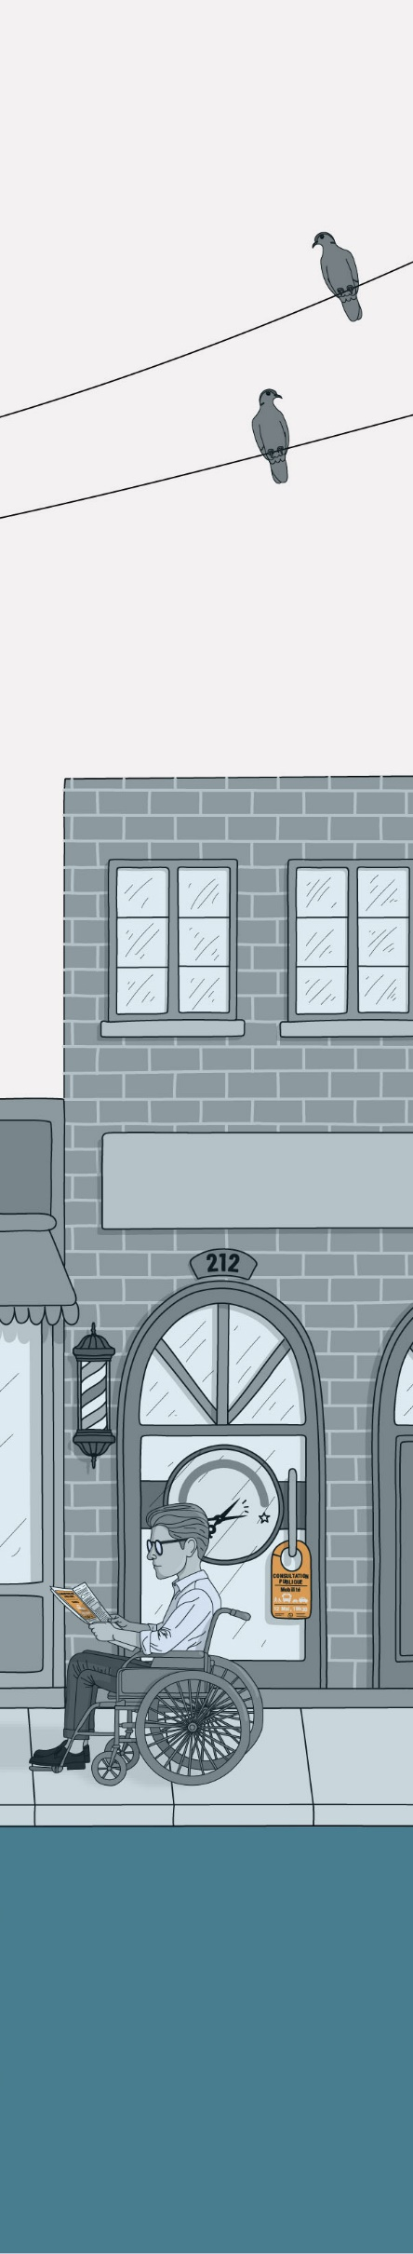
Conclusion
Here is what the project shows:
- Change is possible when staff get training and help.
- Change does not happen quickly. It takes time.
- Sometimes, it’s hard to change how things are done. Sometimes we need to start the work over many times.
- To make change happen, we have to work together in the same direction.
- We make information clearer because we want everyone to understand and be included.

The research is ending but the work is not finished. We have to continue what was started. We have to do more for people with disabilities.

We hope that clear communication, in different formats, will help everyone understand the information so they can participate fully in their community.

