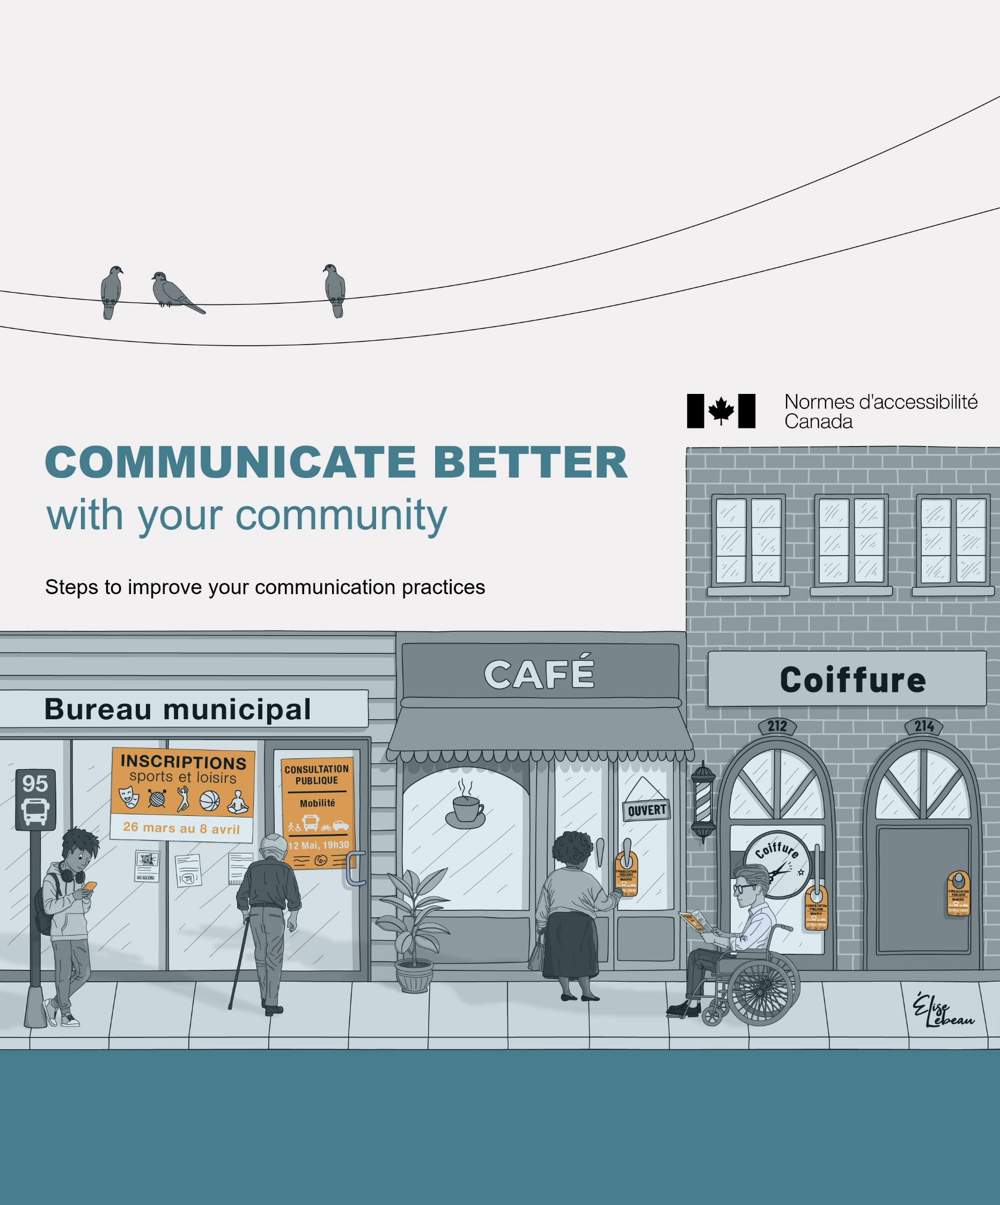
Edith Jolicoeur, Julie Ruel, Marie-Josée Goulet, Marie-Ève Gonthier, Francine Julien-Gauthier

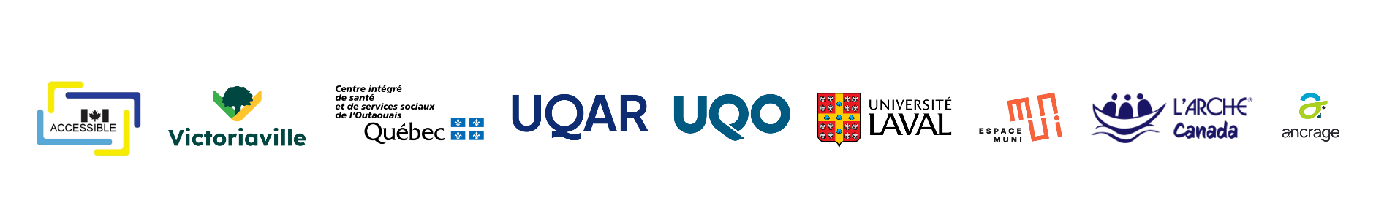

This document is an appendix to:
Jolicoeur, E., Ruel, J., Goulet, M.-J., Gonthier, M.-E., & Julien-Gauthier, F. (2026). Communicate better with your community: Steps to improve your communication practices. Université du Québec à Rimouski. https://doi.org/10.65130/pe7bt4z


This guide is published under a Creative Commons Attribution 4.0 International (CC BY 4.0) license. You are free to share and adapt it, provided that you give appropriate credit to the authors.

Acknowledgements and financial support
This research was made possible through the financial support of Accessibility Standards Canada (ASC). Support for a portion of the quantitative data analysis from the questionnaire was provided by the Institut universitaire en déficience intellectuelle et en trouble du spectre de l’autisme (IUDITSA).
This project benefited greatly from the collaboration of a valued colleague, André C. Moreau. We also wish to highlight the contribution of Marie-Ève Lefebvre, professor at Université du Québec à Rimouski (UQAR).
The analyses were also made possible by the meticulous work of these research officers: Marie-Ève Bolduc, Jessica Lacroix, Martine Lorrain-Cayer, and Léa Dufour.
We extend a very special thank you to the residents of L’Arche Canada and the staff members who work there daily. Thank you for opening your doors to us.
Finally, we would like to acknowledge the contribution of the staff of the City of Victoriaville, in particular Nathalie Roussel, Strategic Advisor, as well as Fanny Landry, Director of the Communications and Citizen Relations Department, and her team. Their dedication was a key driving force behind this research. We also thank Rosalie Courtois, Communications Officer throughout the duration of the project. Finally, this project would not have been the same without the active participation of the members of the two communities of practice.

Table of Contents

Section 1 5
Why this guide? 5
Why improve your communication practices? 6
Why focus on clear communications? 7
Where to start 8
Section 2 9
Communicating better is a type of innovation 9
Section 3 11
Suggested steps to communicate better 11
Section 4 18
Examples of improved city communications 18
Ce qu’on retrouve dans la version finale 20
Ce qu’on retrouve dans la version finale 23
Ce qu’on retrouve dans la version finale 26
Ce qu’on retrouve dans la version finale 29
Conclusion 30
References 31



Section 1

Why this guide?

We wrote this guide after doing a research project with the city of Victoriaville, which is in Quebec. The goal of this research was to help the city government, which wanted to communicate better with the people in the city. Thanks to a grant from Accessibility Standards Canada (ASC), we tested and gathered the best ways to help other cities and organizations that want to work at making their communications clearer and start a process like the one we did.

This guide is part of that process. It aims to show the steps needed to begin this type of work.

Why improve your communication practices?

The main reason to improve your communication practices is to reach more people in your community. In Quebec, 52% of people between the ages of 16 and 65 do not have the literacy level they need to function well in society (Langlois, 2025). On the website of the Organisation for Economic Co-operation and Development (OECD), literacy is defined as “understanding, using, evaluating, reflecting on, and engaging with texts in order to achieve personal objectives, enhance knowledge and capabilities, and contribute to society” (OECD, 2026).

Some people are more likely to have a lower literacy level than on average for the population (OECD, 2024). In general, the following factors can lead to lower literacy:
- age of 55 and older,
- not having a high level of education,
- being an immigrant or allophone (this means people who speak a language other than English or French at home),
- being from a low-income background,
- living with disabilities.

Every city gains from using plain language in its communications. It helps people with low literacy levels understand information better. In fact, plain language aims to “provide communication that is equitable, inclusive, and barrier-free” (ASC, 2025). In the end, plain language lets more people find, understand, and use the information they need (ASC, 2025).

Why focus on clear communications?

When your communications are clearer, you gain several advantages (ASC, 2025):
- You make public services work better. Information is easier for people to find, understand, and use.
- You improve fairness. When you remove barriers to communication, you bridge the gap between people who understand the information and those who do not.
- You get fewer questions, misunderstandings, and mistakes when the information is clear.
- You become a trusted source. When you give reliable and accurate information, you improve your relationship with the community.
- You encourage everyone to participate. Clear communication helps all people take part in city life.

Where to start

This guide offers a suggested way to help you improve how you communicate. To learn more about how to write in plain language, you can see the guide called Communiquer pour tous, which means “communicate for everyone” (Ruel et al., 2018). For English summaries of the guide, you can read these Practical memos (Allaire and Ruel, 2023).

In the next sections, we show how improving your communications is a type of innovation. Then, we suggest a simple way to help you take action. Lastly, we give real examples of rewritten communications. These follow the principles of clear communication to encourage you to adopt these practices in your own work.


Section 2

Communicating better is a type of innovation

Improving how you communicate is a form of innovation. In a city setting, “innovation is simply what cities do to adapt, improve their services and management, meet the needs of residents, and solve the problems they face” (Beaudet and Shearmur, 2019, p. 53).

Innovation is a group process. It is done by many people working together. It is also intentional, meaning it is done on purpose (Gather Thurler, 2004). If your city chooses to innovate, your staff will work together to improve your communication practices.

Cities that want to innovate by improving their communications must first make sure this is a real need. They must check that their community needs to be able to find, understand, and use city information.

Innovation has to use knowledge from research or from similar past experiences. This knowledge guides the steps your city can take to meet the needs of the people who live there.

Sometimes, change is hard to start. You can start with “allies,” or staff members who are already interested in innovation. If this is already in place in your city, you can then spread the change to other departments or organizations.

In this guide, we adapt the innovation process to the daily work of cities that want to improve how they communicate. In the next section, we show you how this works.



Section 3

Suggested steps to communicate better

Does your city want to make it easy for the people who live there to find, understand, and use the information they need? You can do this by improving your communication practices.

In this section, we suggest 5 steps to help make your communications clearer. These steps are built on research and on the experience of organizations that wanted to improve how they talk to their different audiences.
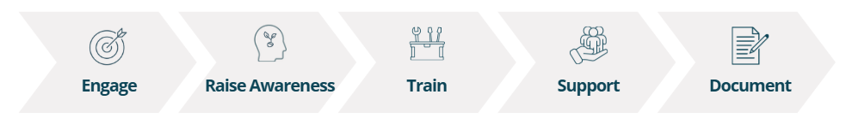

Step 1 Involve everyone in the organization

It is important that your leaders support the move to improve communication practices. Their support convinces people that the project is important. It also encourages all staff members to take part in it. When a lot of different staff members participate, they feel more connected to the project.

Changes backed by your organization’s leaders are more likely to last. Remember to include the elected people in your city.

Step 2 Let all staff members know why clear communication is important

Surveys on literacy skills show that many people in Quebec have trouble finding, understanding, evaluating, and using written information.

This is why it is necessary to teach your staff about clear communications. This helps everyone, including elected people and city employees, understand why the city is taking these steps.
The information can focus on the following goals:
- Learn about literacy levels in Canada, Quebec, and your local region.
- Recognize different groups that may need extra help.
- Understand the difficulties and the results of having different literacy levels.
- Recognize the most important times to use clear communication. Examples include information on when waste is picked up and instructions to use in case of emergencies.
- Follow the law regarding access to information for everyone, especially for people with disabilities.
- Explore how to become a pro-literacy city. This means being a city that considers the different skills of all the people who live there

Step 3 Train your staff in clear communication practices

Training is a good way to support your staff and give them the tools they need for clear communication. Anyone who tries to communicate clearly soon realizes that making things simple is actually quite complex.
Training can focus on the following goals:
- Learn the different steps of clear communication.
- Find ways to involve your audience at every stage of creating your communications.
- Learn the best ways to use plain language in the following situations:
  - writing information,
  - creating and using images,
  - creating information for the web and digital devices,
  - speaking to others.
- Apply these best practices to different city situations.

Step 4 Help staff adopt clear communication over the long term

Giving information and training are important steps. But, they are not enough to make long-lasting changes in your city, even with a motivated staff. Changing how we work takes time, both in daily tasks and over the long term.

Putting support measures in place helps staff members adopt these new practices and keep them going over time.
Here are some support measures to help staff adopt clear communication:
- Give them time and resources, like in the following examples:
  - Choose one or more people in your organization to act as experts on clear communication. They can then help their coworkers.
  - Create or find an internal team to review communications.
  - At each team meeting, talk about a piece of communication that was created by a team member. This helps everyone keep improving.
  - Use a testing group made up of different people from your target audience to check your work.
  - Offer different types of help, to match how people learn. Not everyone learns at the same speed or in the same way.

- Start one or more communities of practice.
  - These groups bring together staff members who volunteer to improve their communication skills.
  - Group members meet at preset times to show the communications they have created.
  - Talking with coworkers allows everyone to give comments, ask questions, and think together about the best way to share information. Everyone must keep an open mind in these talks, when giving or receiving comments.
  - A person from inside or outside the organization can lead these groups.

- Give staff practical tools like these:
  - Writing guides or reference guides
  - Checklists or practical memos
  - Templates for letters, emails, public notices, fact sheets, and more.

Step 5 Keep notes on the changes you make

Keeping different versions of your communications helps show how your city is making its communications clearer.
Since it is easy to forget how much has changed, we encourage you to save the different versions of any documents you have improved.

You can use these documents for the following:
- To use as templates for future communications
- To help new staff and encourage them to better their communications
- To help you remember and show your successes to others
- To show the actual changes made throughout the whole process.

These tools help create a positive environment for change. The next section provides examples of city communications that were improved using this process.



Section 4

Examples of improved city communications

The steps shared earlier provide a guide for making communications better. In this section, we show how a document can change, as small adjustments are made. For each example, you will see a starting version, an improved version, and a list of the main changes made to make it easier to understand. These examples can be used as templates and adapted to fit your own needs.

Exemple 1 : Urban Planning Department Lettre – Sent via Email
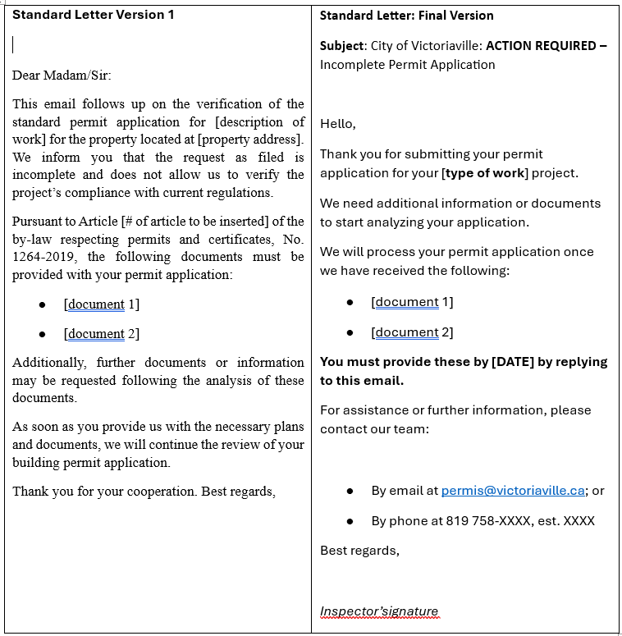

Key Improvements in the Final Version

- Explicit subject line added: “Incomplete Permit Application,” and specified that action is required.
- Used “Hello” instead of “Dear Madam/Sir.” This should be used when the gender of the person you are communicating with is unknown.
- Used “we” and “you” instead of a neutral, bureaucratic tone to address the individual directly.
- Included the specific inspector’s signature for a more personal touch.
- Used familiar words and maintained consistent terminology. For example, “application” is used throughout instead of alternating between “application” and “request.”
- Omitted by-law and article numbers, as they are not essential to the individual’s immediate task.
- Listed actionable information:
  - Provided a specific deadline and clear instructions on how to submit missing documents;
  - Included precise contact information for help or follow-up questions with the Urban Planning Department.
- Generous use of white space.
- Used unjustified, left-aligned text.
- Used active rather than passive sentence structures.
- Bolded text to highlight critical information.
- Chose a sans-serif typeface, which is generally easier to read in short texts.

In both versions, bulleted lists were used to clearly present the required documents, allowing the recipient to quickly identify these documents.

Exemple 2 : Poster on the Emerald Ash Borer
Poster Text: Version 1 (Pre-Image Integration)
Offensive Against the Emerald Ash Borer
The emerald ash borer is an invasive insect that attacks and kills all species of ash trees.
To prevent the spread of the infestation, we must fell several ash trees.
To compensate for the cutting, several trees have been planted, and planting will continue.
To learn more, visit: vic.to/agriledufrene.

Final Poster Text and Imagery:
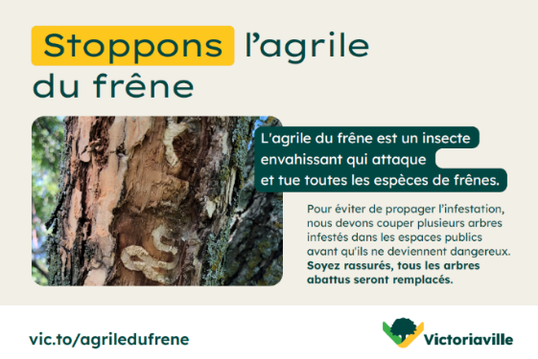

Key Improvements in the Final Version

- Simplified messaging:
  - Changed “Offensive Against the Emerald Ash Borer” to “Stop the Emerald Ash Borer,” which is more direct and engaging.
  - In the second sentence, replaced “In order to” (Afin de) with the simpler “To” (Pour), which is more direct and easier to process.
  - Used “Stop the insect from spreading” rather than “prevent the spread.” Using a verb is more direct.
  - Used “cut down” instead of the technical forestry term “fell.” “Cut down” is much more common in everyday language.
  - Le texte qui sert de légende est à proximité de l’image.
- Placed the text acting as a caption close to the image it describes.
- Linked the image directly to the caption text, visually demonstrating the damage caused by the emerald ash borer.
- Added a supportive message addressed directly to the public: “Rest assured, all trees that are cut down will be replaced.”

Exemple 3 : Door Hanger on Water Usage
Version 1 of the Door Hanger
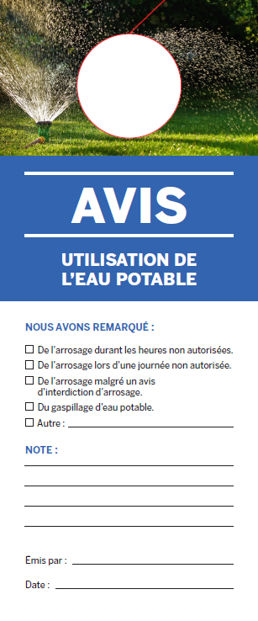 | 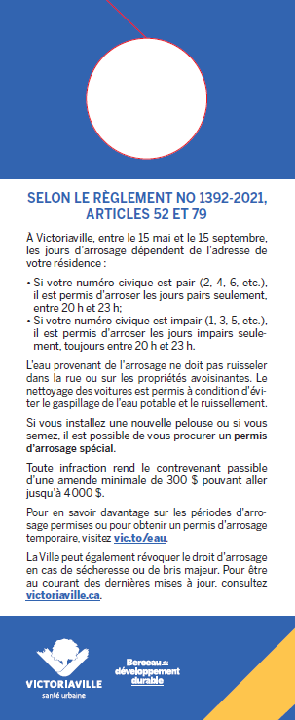

Final Version of the Door Hanger
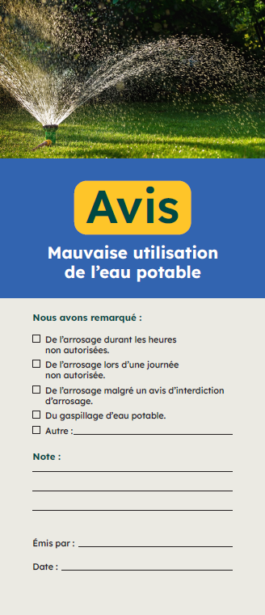 | 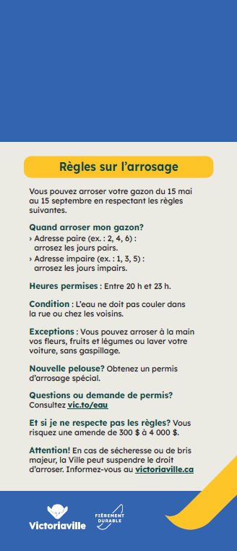

Key Improvements in the Final Version

- Clear title: “Unauthorized Use of Drinking Water.”
- By-law and article numbers were removed as they are non-essential for this type of notice. Instead, the back is titled “Watering Rules.” This heading and content is much more relevant to the residents receiving the notice.
- Content is organized using subheadings to indicate the type of information presented. This allows recipients to scan the notice quickly and find the specific details they need.
- Explicit subheadings are short, descriptive, and emphasized in bold.
- Unjustified, left-aligned text is used.

In both versions, most of the message uses a direct “you” tone to engage the reader: First version: “If you install a new lawn...” Final version: “You may water by hand...”

Exemple 4 : Public Notice
Original Version
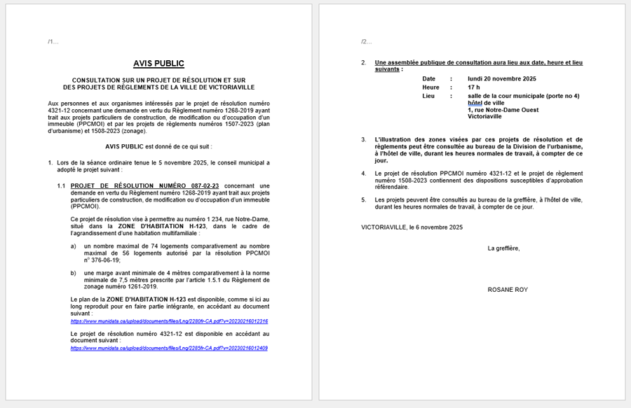

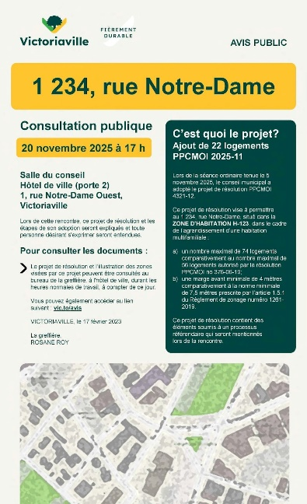
Final Version

Key Improvements in the Final Version

- The specific project under public consultation and its address are clearly highlighted at the very beginning (answering the question: “What is the project?”).
- The project description uses clearer, more accessible language.
- An illustration of the affected neighbourhood and the specific property.
- The date, time, and location of the consultation are prominently displayed.
- The notice provides only the information the public needs to understand the notice.
- The redesigned notice is shorter, condensed from two pages down to one.
- Adding columns and colour makes it more visually appealing.
- Unjustified, left-aligned text is used.

Conclusion

The change suggested in this guide is long-term work. You may work hard and still find that some challenges or barriers remain. At the same time, it is hard to create communications that work for everyone, especially people with disabilities. But every improvement counts. Using a clear main message, shorter sentences, and helpful headings makes a difference. Better navigation and a clean layout also help. These changes reduce barriers for people in the community.

Finally, you can combine several tools: plain language, different formats, and testing your work with real people. Clear communication is built over time. You will need to test, adjust, and note what you learn to keep the work going.

We hope this guide is useful to you. This guide belongs to you. We hope this process benefits your entire community.

References
Accessibility Standards Canada (ASC) (2025). CAN-ASC-3.1: 2025 – Plain Language. https://accessible.canada.ca/creating-accessibility-standards/can-asc-312025-plain-language/6-introduction
Allaire, C. et Ruel, J. (2023). Communiquer pour tous. Mémos pratiques. Santé publique France. https://www.santepubliquefrance.fr/recherche/#search=m%C3%A9mo%20pratique
Beaudet G. and Shearmur, R. (2019). Municipal innovation. Sortir des sentiers battus. Les Presses de l’Université de Montréal.
Gather Thurler, M. (2004). Stratégies d’innovation et place des acteurs. In J.-P. Bronckart and M. Gather Thurler (Eds.), Transformer l’école (pp. 99–125). De Boeck.
Langlois, P. (2025). PEICA Canada 2022. Analyse des nouvelles données publiques pour le Québec. Fondation pour l’alphabétisation. https://fondationalphabetisation.org/alphareussite-10/
Organisation de coopération et de développement économiques (OCDE) (2024). Les adultes possèdent-ils les compétences nécessaires pour s’épanouir dans un monde en mutation ? : Évaluation des compétences des adultes 2023, Études de l’OCDE sur les compétences. Éditions OCDE.
Organisation for Economic Co-operation and Development (OECD) (2026). Adult literacy skills. https://www.oecd.org/en/topics/literacy-skills.html
Ruel, J., Allaire, C., Moreau, A.C., Kassi, B., Brumagne, A., Delample,
A., Grisard, C. et Pinto da Silva, F. (2018). Communiquer pour tous.
Guide pour une information accessible. Santé publique France. https://docs.google.com/viewerng/viewer?url=https://uqo.ca/sites/default/files/1560044842communiquer-pour-tous.pdf

